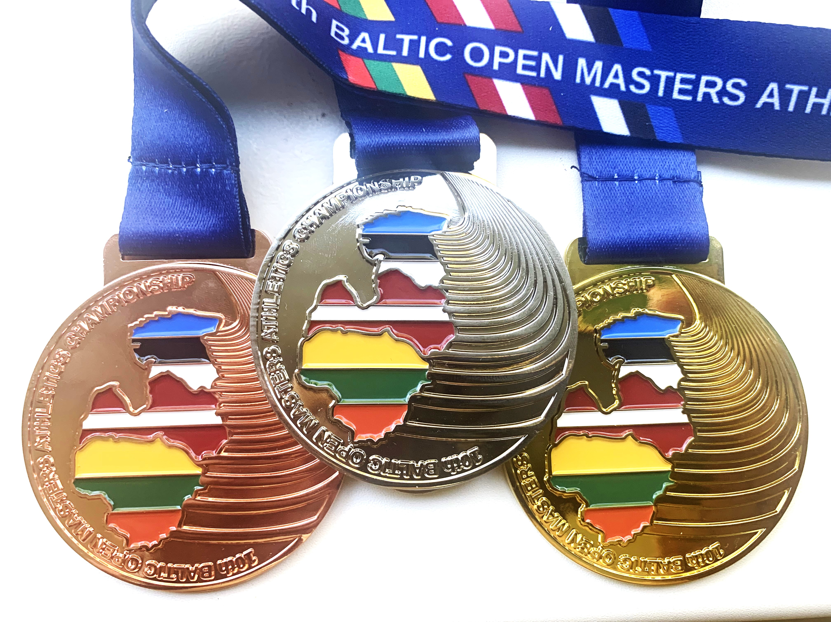

ESTONIAN AND BALTIC OPEN CHAMPIONSHIPS IN ATHLETICS 2023.
COMPETITION GUIDE

1 GOALS:
-to popularize the athletics among seniors.
-to identify best senior athletes of 2023 in Estonia and Baltic countries.
-to strengthen sports relations between the Baltic and neighboring countries among the senior athletes.

2. PLACE AND TIME
Competitions are held on the 12.-13. of August at the Kadriorg stadium of Tallinn city. Competition starts on the 12. August at 11:45 and on 13. August 2023 at 10.00. The timetable is included in the supplement after registration ends.

3 PARTICIPANTS AND PROGRAM
Championships are open to all senior around the world except Russian and Belorussian athletes. There are the following age categories:
M35, M40, M45, M50, M55, M60, M65, M70, M75, M80, M85, M90 + ;
N35, N40, N45, N50, N55, N60, N65, N70, N75, N80, N85 + ;
Each competitor is responsible for their own state of health. The age of the competitor is determined by the age on the 12nd of August. The program contest is:
Women : 100m, 200m, 400m, 800m, 1500m, 5000m, 5000m walk, high jump, long jump, triple jump, shot put, discus, javelin, hammer, weight.
Men : 100m, 200m, 400m, 800m, 1500m, 5000m, 5000m walk, high jump, long jump, triple jump, shot put, discus, javelin, hammer, weight.

Participants of long jump, triple jump and throwing events have three qualification attempts for each age group and six best of each age group have three final attempts.

4 REGISTRATION
Preregistration for the competition is open until 10 of August 2023 by link https://my.raceresult.com/240926/ our web-site www.kjveteranid.ee võistlused/juhendid only. Changes are available in the stadium before competition from 10:00 to 12:00 AM. Entry fee until 10 of August 2023.a. is 20 € for one event and 6€ for every next event should be transferred to the EKVA bank account Eesti Kergejõustikuveteranide Assotsiatsioon IBAN: EE941010102032127001 AS SEB PANK SWIFT CODE (BIC): EEUHEE2X
Confirmation and getting the personal competitors’ numbers is from 10.00-11.30. Without numbers nobody is allowed to start.

5 ORGANIZER
General organizer is Estonian Masters Athletics, shortened EstMA, in Estonian - Eesti Kergejõustikuveteranide Assotsiatsioon (EKVA, info: www.kjveteranid.ee ,e-mail: author@author.ee , phone: +372 5039663).

6 PRIZES
I, II , III place winners in the Baltic championships will be awarded with Baltic Championship medals in each age category. The three best Estonian athletes will get the medal as Estonian Championship. Estonian best athletes get the medal of Estonian Olympic Committee. Victory ceremony will take place immediately after competition finish or according to victor ceremony schedule.

7 MANAGEMENT
Participation expenses shall be born by the sending organisations or the participants themselves. EKVA has made some reservations for groups in hotel Dzingel, information till 31.05.2023 from Lembit Talpsepp +3725039663.

8 GENERAL
All non-defined problems will be solved by the organizer of the competition together with the chief judge and a representative of EstMA. Competitions are held according to IAAF and WMA regulations.
Chief judge: Mr. Peeter Randaru, technical delegate: Katrin Polli. Copetitions are supported by Estonian Ministry of Culture, Tallinn City and Estonian Culture Capital.

9. INFORMATION AND CONTACTS
Info about competition is on web-page www.kjveteranid.ee, or by e-mail: author@author.ee, or from the competition director Peeter Randaru or from President of EstMA Lembit Talpsepp +3725039663.

BALTIC AND ESTONIAN MASTERS OPEN CHAMPIONSHIPS IN ATHLETICS 2023

12.-13. August 2023, Tallinn, Kadriorg stadium

Day 1

12.00 100 m M60+
Triple Jump W35+ (main arena)
Shot Put M70+ (warm up arena)
Discus Throw W35-55 (warm up arena)
Javelin Throw M50-55 (main arena)
Weight Throw W60+ (warm up arena)
12.30 100 m M35-55
13.00 100 m W35+
Weight Throw M60+ (warm up arena)
13.15 Triple Jump M35+ (main arena)
13.30 1500 m M35+
Shot Put M50-55 (warm up arena)
Discus Throw M35-45 (warm up arena)
Javelin Throw M60-65 (main arena)
14.00 1500 m W35+
Weight Throw M35-55 (warm up arena)
14.05 Awarding Ceremony (for events ended at 13.30)
14.30 400 m M35+
High Jump M35+ (main arena)
High Jump W35+ (warm up arena)
15.00 400m W35+
15.00 Shot Put M60-65 (warm up arena)
Discus Throw W60+ (warm up arena)
Javelin Throw M70+ (main arena)
Weight Throw W35-55 (warm up arena)
15.05 Awarding Ceremony (for events ended at 14.45)
16.05 Awarding Ceremony (for last events of the day)

Day 2

10.30 5000 m RW W,M35+
11.00 Long Jump W35-50 (main arena)
Hammer Throw M35-45 (warm up arena)
12.00 200 m W35-50
Shot Put W35-55 (warm up arena)
Discus Throw M60-65 (warm up arena)
Javelin Throw W60+ (main arena)
Hammer Throw M70+ (warm up arena)
12.15 Long Jump W35-50 (main arena)
12.20 200 m W55+
12.30 Awarding Ceremony (for events ended at 12.15)
12.40 200 m M35-50
12.45 Hammer Throw M60-65 (warm up arena)
13.20 200 m M55+
13.30 Long Jump M35-55 (main arena)
Shot Put W60+ (warm up arena)
Discus Throw M50-55 (warm up arena)
Javelin Throw M35-45 (main arena)
Hammer Throw W35-55 (warm up arena)
13.40 800 m W35+
14.00 800 m M35+
14.05 Awarding Ceremony (for events ended at 13.45)
14.15 Hammer Throw W60+ (warm up arena)
14.20 5000m M35+
14.45 Long Jump M60+ (main arena)
14.50 5000m W35+
15.00 Shot Put M35-45 (warm up arena)
Discus Throw M70+ (warm up arena)
Javelin Throw W35-55 (main arena)
Hammer Throw M50-55 (warm up arena)
15.20 4x100 m Relay W
15.30 4x100 m Relay M
15.45 Awarding Ceremony (for last events of the day)

Competition Director: Peeter Randaru
Technical Delegate: Katrin Polli

